A000-Am,S-Colombia, Tairona, Rattle-Tumbaga-1000–1500 CE.

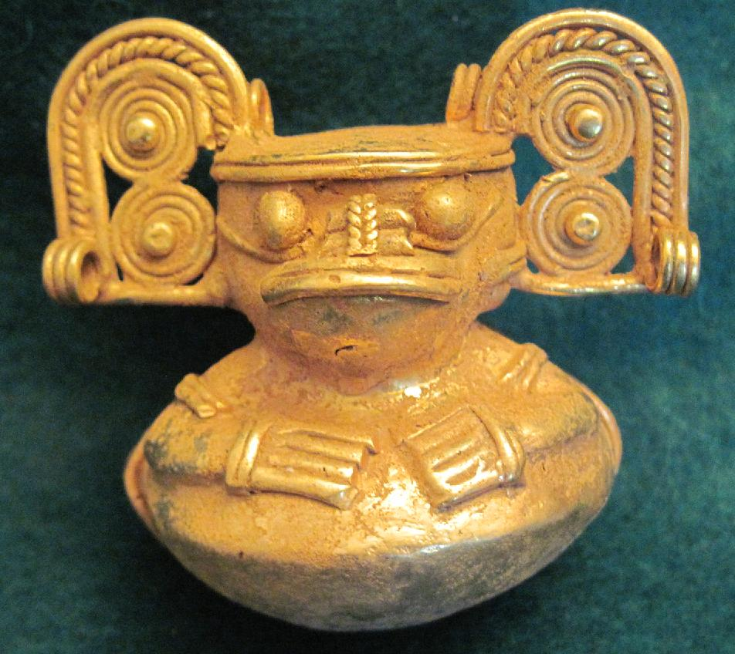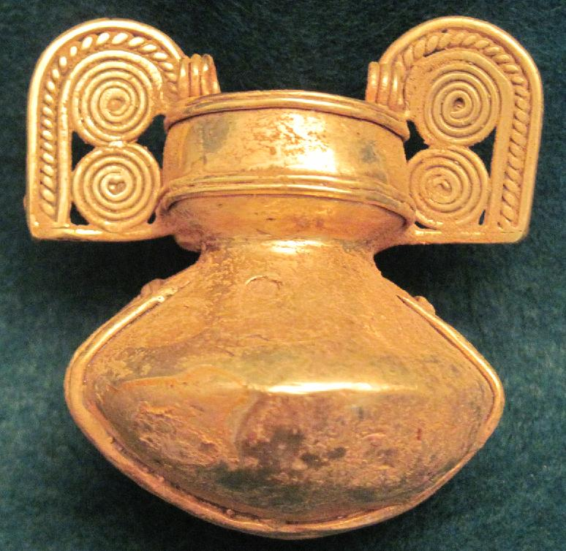

Figs 1-2. Colombia, Tairona, Rattle-Tumbaga-1000–1500 CE.

Case No.: 7

**Accession No.**

**Formal Label:** Colombia, Tairona, Rattle-Tumbaga-1000–1500 CE.

**Display Description:**

This rattle or bell was produced by the lost wax process and depicts a prominent personage with a rotund belly fashioned into a sound-making device (idiophone) with a slit in the bottom to allow the sound to escape and a globule of tumbaga in the ell to make the rattling sound. The figure is depicted with an elaborate headdress, arm bands and bracelets. The MMA specimen is similar except that the figure has a labret or lower lip plug.

**LC Classification:**

**Date or Time Horizon:**

**Geographical Area:**

**Map:**

**GPS coordinates:**

**Cultural Affiliation:**

**Media:**

**Dimensions:** 3.5 x L. 4.3cm. (1 3/8 x 1 11/16in.)

**Weight:**

**Condition:**

**Provenance:**

**Discussion:**

**References:**

Appendix:

Other Examples:

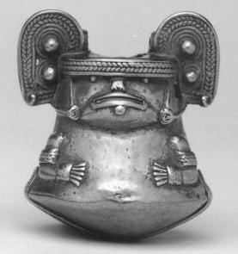 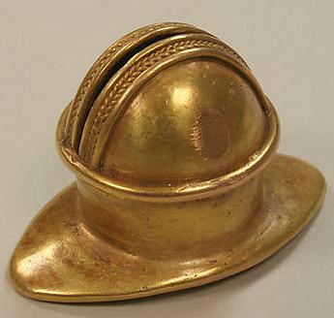

Colombia, Tairona. Left: Rattle or Bell (Idiophone), 1000–1500 CE, Tumbaga (alloy of gold and copper), Diam. 3.5 x L. 4.3cm. (1 3/8 x 1 11/16in.); MMA (Accession Number: 2004.49); right: Labret, 1000–1500 CE, Tumbaga, W. 2 in. (5.1 cm).